**Module 19**

**Name: Upadhyay Sachin Naresh**

**Batch id: AIWDEOB 300821**

**Topic: GANs and Types of GANs**

Explain the detailed steps to train a GAN model. Also explain on the architecture of SRGAN?

Answer:

### Steps to train a GAN Model:

**Step 1: Define the problem.**To generate fake images or fake text should completely define the problem and collect data for it.

**Step 2: Define architecture of GAN.**Define how GAN should look like. Should both generator and discriminator be multi-layer perceptron, or convolutional neural networks etc. This step will depend on what problem trying to solve.

**Step 3: Train Discriminator on real data for n epochs.**Get the data that want to generate fake on and train the discriminator to correctly predict them as real. Here value **n** can be any natural number between 1 and infinity.

**Step 4: Generate fake inputs for generator and train discriminator on fake data.**Get generated data and let the discriminator correctly predict them as fake.

**Step 5: Train generator with the output of discriminator.**Now when the discriminator is trained, can get its predictions and use it as an objective for training the generator. Train the generator to fool the discriminator.

**Step 6: Repeat step 3 to step 5 for a few epochs.**

**Step 7: Check if the fake data manually if it seems legit. If it seems appropriate, stop training, else go to step 3.**

Pass 1: Train discriminator and freeze generator (freezing means setting training as false. The network does only forward pass and no back propagation is applied)

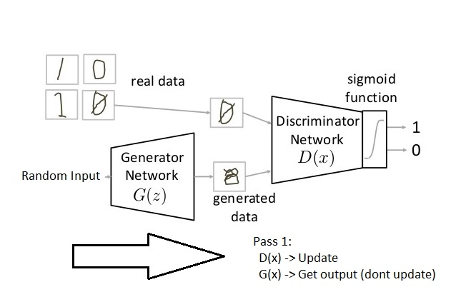

Pass 2: Train generator and freeze discriminator

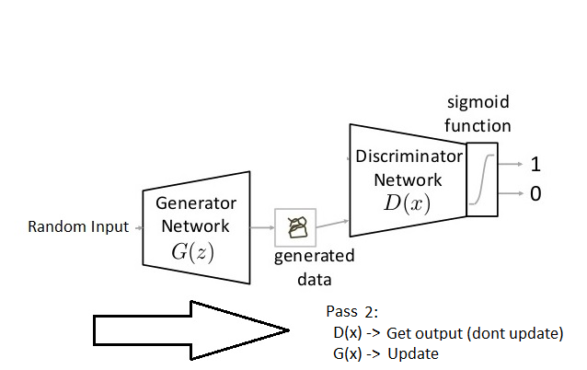

Architecture of SRGAN

The Super Resolution GAN also contains two parts Generator and Discriminator where generator produces some data based on the probability distribution and discriminator tries to guess weather data coming from input dataset or generator.  Generator then tries to optimize the generated data so that it can fool the discriminator. Below are the generator and discriminator architectural details.

During the training, A high-resolution image (HR) is down sampled to a low-resolution image (LR). A GAN generator up samples LR images to super-resolution images (SR). We use a discriminator to distinguish the HR images and back propagate the GAN loss to train the discriminator and the generator.

